**User Screen**

1. First, the user search for a book using ISBN, Title, or Genre.

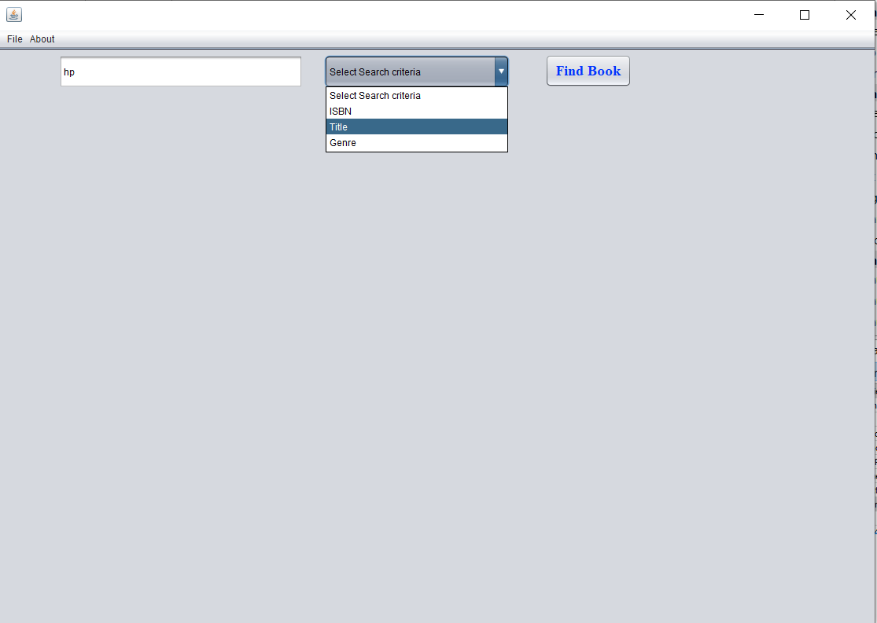

1. Then, all the books that match the word appear to the user to select between them and then, click buy.

1. Then, the user adds the quantity, shipping, and billing address and then new order is created with this book.

**Owner/Manager Screen**

1. First, the owner can add a new author, new publisher, or new book.

